Initial Self-Evaluation Form - Flaming Physical Therapy
11 Elsinore Avenue, Bath 207-442-9810 68 Chapman Street, Damariscotta 207-563-7990
Patient’s Name: ________________________________ Date: _______________
Date of Original Injury, symptoms or Pain: ___________ Date of Birth: _______________
PRESENT CONDITION / PAIN / SYMPTOMS:
- Please Shade or make an “X” in area (or areas) where you are experiencing pain /symptoms.
- If the symptoms travel/radiate, use an “arrow” to follow the path of pain
- Feel free to use more than one symbol
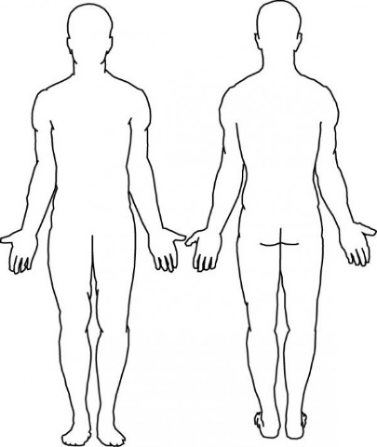
- Current Injury/Symptom Descriptors: Circle any/all words that apply, add others

- When and what initially caused you to seek Physical Therapy? ________________________
_________________________________________________________________________
- List symptom(s) that you “INITIALLY” experienced ________________________________
  - Severity Initially: 0 1 2 3 4 5 6 7 8 9 10

- List Symptom(s) that you “CURRENTLY” experience ________________________________
  - Severity Currently: 0 1 2 3 4 5 6 7 8 9 10

- Since Initiation, how has the pain changed? _______________________________________
Initial Self-Evaluation Form – Flaming Physical Therapy (Continued)

- Since onset have your symptoms become:
  - BETTER B. WORSE C. No CHANGE
- How often do you experience the Symptoms? ________________________________

- What makes your symptoms Worse?
Sitting Standing Walking Bending Lifting Other
- What eases your Symptoms
Sitting Standing Walking Bending Lifting Other
- How much does your pain interfere with your activities?
  - None (0%) Rarely (1-19%) Often (20-39%)
  - Moderate (40-59%) Almost always (60-79%) Always (80-100)
- Are you taking any Medications related to the reason you’re in PT? YES NO
  - If yes, What and how often? ________________________________
PAST HISTORY OF SYMPTOMS
- Have you ever had these kinds of symptoms before? YES NO
If Yes, when was the previous episode? ________________________________
- How often have they reoccurred? _______________________________________

- Has the frequency of severity of these symptoms increased since that former episode?

  - FREQUENCY? YES NO B. SEVERITY? YES NO
PAST MEDICAL HISTORY
Accidents or injuries? YES NO _________________________________
Surgeries? YES NO _________________________________
Cancer? YES NO COPD YES NO
Arthritis YES NO Neurologic Disorders YES NO
Pregnancy? YES NO Parkinson’s YES NO
Immunosuppression? YES NO Pacemaker YES NO
Have you had other related P.T. or Body work? __________________________
By signing, I certify that all information in this form is true and correct to the best of my knowledge.
Patient (or Guardian) Signature: ________________________________ Date: _________

